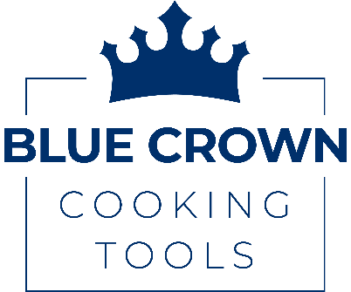

February 16, 2026
Press Release
Blue Crown Cooking Tools Launches the Geo Ground Meat Cooking Tool – A Faster, Smarter Way to Cook Ground Beef
American, Women-Owned Small Business Introduces Patented Grid Design to Transform Everyday Cooking
TAMPA BAY, FL – Blue Crown Cooking Tools, an American, women-owned small business, proudly announces the launch of the Geo Ground Meat Cooking Tool, an innovative kitchen utensil designed to make cooking ground beef easier, faster, and more efficient.
Ground beef is a staple in kitchens across America – versatile, affordable, and high in protein. Yet cooking it often requires constant chopping and stirring with traditional wooden spoons, spatulas, or “star” tools. The Geo Ground Meat Cooking Tool eliminates that frustration with a patented grid design that quickly and evenly breaks up ground meat for consistent results every time.
Purpose-engineered from start to finish, the Geo features a reinforced handle and a dual-function design: a front blade to chop larger pieces and a precision grid base to rapidly break meat into fine, uniform crumbles. The result? Faster cooking, less effort, and perfectly cooked ground meat for tacos, spaghetti, casseroles, soups, and more.
Constructed from premium, high-quality nylon and silicone, the Geo is heat resistant up to 450°F, dishwasher safe, and designed with smooth interior grid walls for easy food release and quick cleanup. Its thoughtful design even allows it to rest securely on the pan for mess-free cooking.
“Geo was born from a simple idea – there had to be a better way to cook ground beef!” said Jessica Stewart, founder of Blue Crown Cooking Tools. “As a cost-conscious working mom of two small kids, I found myself preparing a lot of meals with ground beef. The process was simply frustrating, and every little thing that took you away from the stove made cooking ground beef more difficult. We considered every detail in the design of the Geo to solve those challenges. Now cooking ground beef is easier for everyone, from busy individuals wanting to meal prep for a high protein diet to large families making weeknight staples.”
The Geo Ground Meat Cooking Tool is ideal for everyday cooking, meal prep, and makes the perfect gift for housewarmings, newlyweds, holidays, Mother’s Day, Father’s Day, and more.
The Geo Ground Meat Cooking Tool is now available for purchase at www.bluecrowncookingtools.com.

For more information, product images, or media inquiries, please contact:
Jessica Stewart
Blue Crown Cooking Tools
jessica@bluecrowncookingtools.com
www.bluecrowncookingtools.com

About Blue Crown Cooking Tools
Based in Tampa Bay, Florida, Blue Crown Cooking Tools LLC was started with the invention of the Geo Ground Meat Cooking Tool – the ultimate utensil to cook ground beef – and provides high-quality kitchen tools that enhance the cooking experience with a mission to combine innovative design and improved functionality. Blue Crown Cooking Tools is an American, women-owned, small business.
"###"

