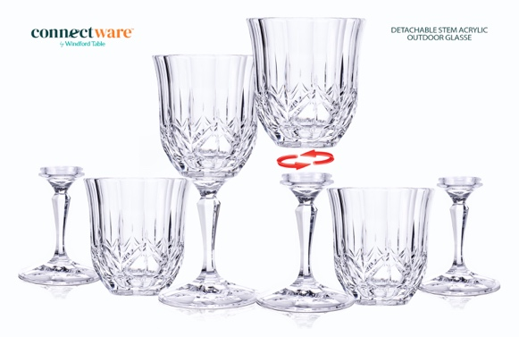
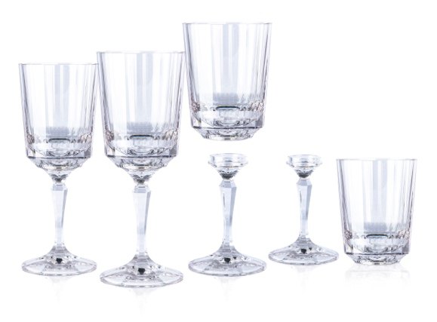
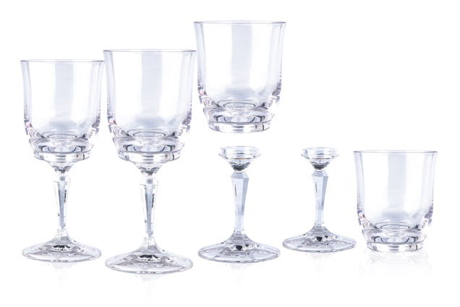

Press Release

Connectware™ by Windford Table
PO Box 92141
RPO Piazza Villaggio
Woodbridge, Ontario, L4H-3J3
www.connectwareglass.com

For Immediate Release: January 16, 2024
Contact:Mirella Sementilli
CEO
Connectware by Windford Table
sales@connectwareglass.com
416-575-1466

Connectware™ by Windford Table Introduces New Detachable Stemware at
The Inspired Home Show being held at Chicago’s McCormick Place March 17-19, 2024.
Woodbridge, Ontario, Canada Connectware™ by Windford Table introduces new designs and colours of desirable detachable stem drinkware for outdoor living. The patent pending 2 in 1 glass offers a twist off stem to use as a tumbler making it easy to stack and store. Connectware twist off stem design offers numerous benefits such as,
- dishwasher safe
- wind resistant due to its weight.
- Detachable stem for a variety of drink options with just 1 glass
- Stackable easy to store in small spaces.
- Industrial dishwasher safe with Ecozen
A crystal like finish and weighted design adds elegance to any venue, and the sparkle is next to none in the outdoor glasses selections. The only drinkware every outdoor event should use at the tiki bar or just about anywhere you want to go. Be sure to visit the Connectware Booth #IC35 in the South exhibition hall to give them a twist for yourself, the 2 in 1 drinkware company releasing new spring colours and patterns.
----more----
Connectware™ by Windford Table Introduces New Detachable Stemware called Connectware™ at The Inspired Home Show 2024

Page 2

The glassware is designed to suit all outdoor environments and venues, and is ideal for poolside entertaining and catered events on an industrial scale.
Connectware patent-pending detachable stem glasses offer the host stress-free prep, since it can be used with or without stem to serve wines or spritzers. Twisting and releasing the stem reveals a tumbler, for serving spirits or mixed drinks with a wedge. This one glass is all that is needed to serve hundreds of coctails.

Its cleverly designed balanced weight allows Connectware to be wind resistant which helps keep the outdoor table setting in place.

Because of its detachable stem option the glasses can stack and be stored in smaller spaces. This is a great benefit for small condo's, boats, cottages and outdoor cabannas.

Made from PBA free Acrylic or Ecozen plastic, the glassware is dishwasher safe for easy clean up, as well as shatterproof and safe to use outdoors.

For more information about Connectware tm by Windford Table, visit www.connectwareglass.com.
Or Youtube channel
https://m.youtube.com/@ConnectwareTMglass

###

