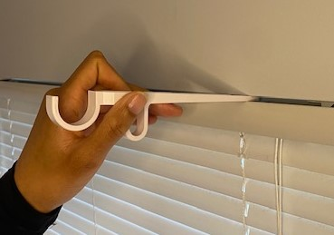

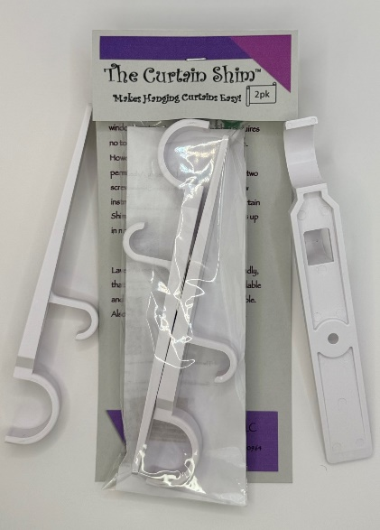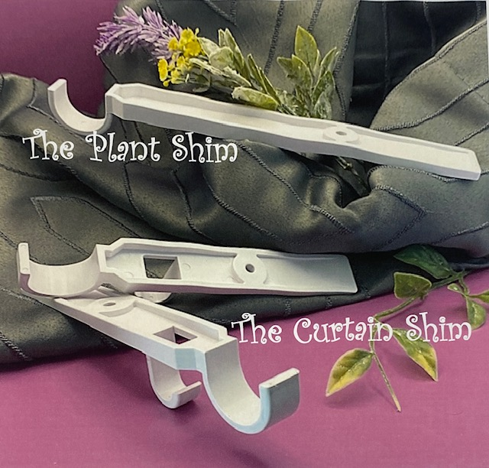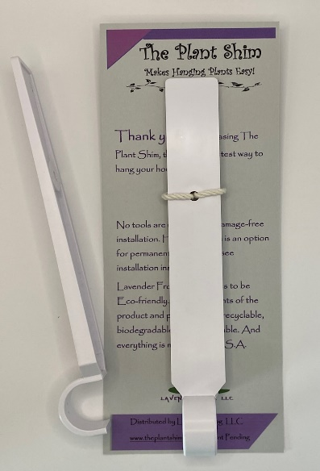

Lavender Frog LLC, The Company, was born from the idea that “there’s got to be a better, simpler way”. Robert Zuchel, the inventor of “The Curtain Shim”, was sitting in his apartment looking at the windows wanting to dress them up, but he was apprehensive about putting holes in the walls to hang a curtain rod. I was staring at the windows when “the space between the blinds and the window frame jumped out at me”, he said. That’s how the idea for The Curtain Shim was born. The Curtain Shim makes hanging curtains easy! Because it requires: No Tools No Measuring No Drilling No Leveling No Damage to walls or moldings and No Moving parts. Just slide it between the window frame and your already installed blinds. That's it! Since the introduction of The Curtain Shim, he has added another Product to the Lavender Frog family, The Plant Shim, which has the same easy installation as The Curtain Shim. Throughout his process to initiate this idea, he developed a work ethic and Motto that he calls K.I.S. (Keep It Simple). Not only does Robert strive to K.I.S., but he also feels we are all responsible for this planet that supports us, therefore he strives to make all components of The Curtain Shim, The Plant Shim, and their packaging as Eco-friendly as possible. And everything is proudly made in the USA.

www.lavenderfrog.com

